- Origin of the MinnesotaCare Taxes: In 1991, the bipartisan “Gang of Seven” legislators and Governor Arne Carlson developed the MinnesotaCare health care reform package that was enacted by the legislature in 1992 and was funded by new MinnesotaCare taxes.

- Rationale for MinnesotaCare Taxes:
  - Policymakers needed a funding source for MinnesotaCare and other state reform programs
  - Policymakers wanted a health care tax for several reasons:
    - A more stable funding source than income taxes, which often decline at the time more people need MinnesotaCare
    - Those paying the tax benefit from the tax by having a source of payment for patients who would otherwise be uninsured.
    - Tax revenues increase at about the same rate as health care costs, keeping pace with MinnesotaCare program costs
  - Policymakers chose two types of health care taxes:
    - Provider tax. A provider tax was the broadest based tax that would spread the tax burden across the entire health care system
      - Insurance premium taxes are not broad based because ERISA prohibits state taxes on self-insured health plans
      - In 1992, all MN payers, including self-insured plans, agreed that the provider tax would be passed through to them
        - Note: Any attempt to mandate self-insured health plans to pay the tax would violate ERISA
    - HMO premium tax. Policymakers added a tax on HMOs and Blue Cross-type plans for two main reasons:
      - These plans would benefit from receiving state contracts to cover the newly insured MinnesotaCare recipients
      - These types of plans did not pay an existing insurance premium tax paid by other types of health insurers

- Uses of MinnesotaCare Tax Revenues: Over time, the Minnesota Legislature has greatly expanded the uses of MinnesotaCare tax revenues by appropriating HCAF money for other state purposes and transferring money from the HCAF to the state general fund. Among other new uses, money was transferred to the general fund to pay for ACA Medicaid expansion when some MNCare enrollees became eligible for MA.

- MinnesotaCare Tax Sunset: In 2011, Governor Dayton and the Republican Legislature reached agreement to repeal the provider tax effective January 1, 2020, as part of their negotiated budget agreement that ended the 19-day state government shutdown.

- Consequences of Repeal of the MinnesotaCare Taxes
  - Loss of funding. MNCare, MA, SHIP, and other HCAF programs are unlikely to be funded at the same level from the general fund
  - Harm to consumers. More people are likely to be uninsured, have fewer insurance benefits and pay higher premiums and copays
  - Public health cuts. SHIP programs that improve the health of Minnesotans are likely to be reduced or eliminated
  - Cuts in provider payments. Health plans will reduce provider payment rates by the amount of the “savings” realized by providers
  - Provider uncompensated care. Cutbacks in state program eligibility, benefits and payment rates will increase uncompensated care losses

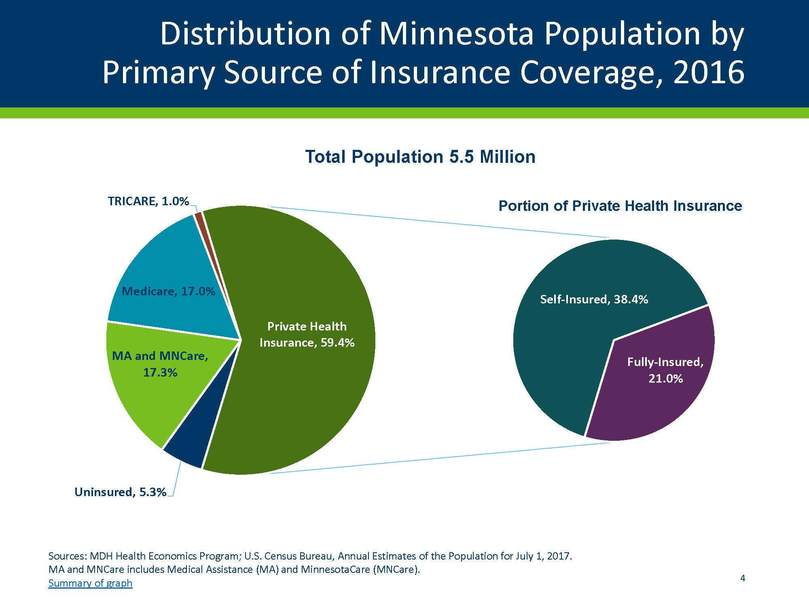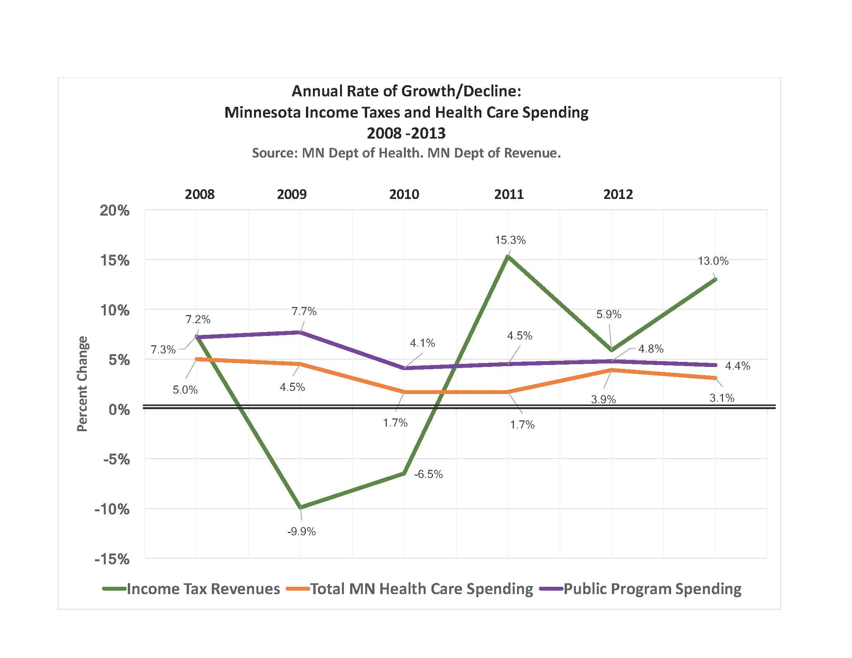
Small Employer and Individual Policies
Large Employer and Union Health Plans
States not allowed to tax
States allowed to tax

